Tab 1

Business Plan
Document Number: GPW-000001
Revision Level: A.02
Released Date: August 12th 2025

Level | Reason | Date | Owner | Approved
A.02 | Data Center Update | 7-Feb-26 | Alfredo Trevino

Table of contents
1. Executive summary 2
2. Business Description 4
2.1. Company Name 4
2.2. Business Structure 4
2.3. Ownership 4
2.4. Location 4
2.5. Company History 4
2.6. Mission Statement 5
2.7. Products or Services 5
2.8. Target Market 5
2.9. Competitive Advantages 5
2.10. Objectives 5
2.11. Vision Statement 6
2.12. Strategic Outlook 6
3. Organization & Management 6
3.1. Ownership 6
3.2. Management team 7
3.3. Advisory Board 8
3.4. Growth Roadmap 9
4. Services 10
4.1. Core services: Turn-Key Final Assembly and Product Engineering 10
4.2. Roadmap & Milestones 10
5. Market Analysis and Strategies 11
5.1. Geographic Markets 11
5.2. Total Available Market 11
5.3. Sales Plan 13
5.4. References 14
6. Funding request 15
6.1. A summary of the business 15
6.2. How much money you’re requesting 15
6.3. What you will use the money for 16
7. Financial Plan 17
7.1. Financial Statement and Budgeting 17
7.2. 5-Year Financial Budget Model 18
7.3. KPI Tracking 18
7.4. Prospective Data 18
7.5. Capital Expenditure Budget 20
8. Full Revision History 21

1. Executive summary
Global Precision Works (GPW) was founded to address the growing demand for dependable nearshoring options as global trade dynamics shift and tariff exposure increases. GPW was formally established in July 2025 and is headquartered in Monterrey, Nuevo León, Mexico—an industrial hub with direct logistical access to North American markets. The company specializes in high-precision integration and final assembly services, with an emphasis on data center solutions that require consistent build quality, disciplined documentation, and reliable execution. The company leverages the founder’s multidisciplinary experience to advance GPW’s mission: delivering smart, high-precision integration and assembly solutions that help customers reduce lead times, improve responsiveness, and increase operational transparency.
Modern infrastructure and industrial organizations face persistent challenges tied to extended global supply chains, geopolitical instability, and communication barriers inherent to offshore manufacturing, particularly in Asia. These constraints create material risks for programs that require tight coordination, rapid engineering iteration, traceability, and predictable output quality. As a result, nearshoring has become increasingly attractive; however, relatively few local partners in Mexico offer the combination of technical rigor, responsiveness, and integrated capabilities required by customers building and deploying complex systems. GPW is positioned as a strategic nearshore alternative focused specifically on integration and final assembly of data center equipment, directly addressing the market need for shorter lead times, improved flexibility, and greater visibility. GPW’s target customer base includes OEMs and Tier 1 and Tier 2 suppliers serving multiple end markets, including automotive, aerospace, medical devices, smart manufacturing, oil & gas, electronics, and data center infrastructure.
GPW’s value proposition, relative to both traditional offshore suppliers and local workshops, is based on a differentiated operating model that combines the technical discipline expected of a Tier 1 supplier with the agility and customer responsiveness of a startup. The company’s competitive positioning is supported by several key differentiators. First, GPW provides a precision-focused nearshoring advantage, combining geographic proximity with high technical standards and reduced lead times. Second, GPW maintains an integration-first approach: enabling tighter process control and clearer accountability. Third, GPW is designed to operate with high flexibility, allowing it to adapt quickly to engineering changes, customer-specific workflows, and evolving program requirements. Fourth, GPW emphasizes digital traceability and quality assurance through the use of integrated tools and structured processes intended to provide real-time visibility, comprehensive documentation, and effective quality management. Finally, GPW operates with a collaborative partnership mindset supported by a bilingual, multicultural team approach aligned with North American business practices and expectations, enabling efficient cross-border communication and operational alignment.
GPW's founding team comprises experienced professionals uniquely qualified to deliver on the company's vision:
- Alfredo Treviño (Chief Commercial Officer): Mechanical engineer with significant experience in international commercial operations, procurement, and strategic customer relationship management.
- Enrique Arrieta (Chief Marketing Officer): Expert in digital marketing, strategic branding, and lead generation, skilled at engaging complex B2B markets.
- Gerardo García (Chief Financial Officer): Financial strategist skilled in corporate finance, analytics, and operational oversight, ensuring sustainable growth and profitability.
- Juan Pablo Jiménez (Chief Operations Officer): Specialist in manufacturing, operations and engineering optimization, with a background in advanced product development and quality management.
As the company continues to grow, the team will be expanded by recruiting additional engineering, operational, administrative, and sales staff, focusing on bringing in talent aligned with the company’s mission and strategic goals.
GPW is currently in its startup phase, having completed formal business establishment procedures in July 2025. The company is strategically located in Monterrey, Nuevo León, a recognized industrial hub near the U.S. border, ideal for manufacturing and logistics. Preliminary market research and partner outreach have confirmed strong industry interest and potential partnerships. The founding team has established key operational processes, developed preliminary supplier relationships, and is actively engaging with initial client prospects to build a robust project pipeline. Additionally, the company has already developed its corporate identity and is actively working on brand positioning strategies to highlight GPW as a strategic partner in the North American market.

2. Business Description

2.1. Company Name
GPW Solutions

2.2. Business Structure
Incorporated (Inc.) (Mexican Legal Structure - SAPI de CV)

2.3. Ownership
The management team consists of:
- Enrique Arrieta: Marketing specialist with extensive digital campaign expertise.
- Alfredo Treviño: Experienced in international sales and strategic procurement.
- Juan Pablo Jiménez: Skilled in manufacturing operations, engineering, and quality management.
- Gerardo García: Expert in financial strategy, analytics, and operational management.
- Luis Alvarez: Business development

2.4. Location
Headquartered in Monterrey, Nuevo León, Mexico, GPW is currently evaluating strategic facility options in the Monterrey Metropolitan Area industrial hub, renowned for their strong manufacturing ecosystems and logistical advantages.

2.5. Company History
GPW – Global Precision Works – was founded in Monterrey, Mexico in 2025 by four longtime friends who first met during their university years as active members of the ASME (American Society of Mechanical Engineers) chapter. After graduation, each founder followed a distinct professional path across sales and marketing, finance, engineering, and manufacturing, building a complementary set of capabilities that now supports GPW’s execution model. This combination of commercial leadership, technical depth, and operational experience positions the team to work effectively with customers that require both disciplined delivery and fast decision-making.
The concept for GPW emerged from the founders’ shared experience operating within complex supply chains and supporting customers with high requirements for schedule, quality, and accountability. Across their careers, the founders repeatedly encountered the same constraints: long lead times from overseas suppliers, limited flexibility when engineering changes were required, and a recurring gap between product design intent and real-world execution. Rather than accept these issues as structural limitations, the founders formed GPW to address them directly through a nearshore operating model focused on integration and final assembly—where responsiveness, process control, and communication are critical to predictable outcomes.
GPW was launched in response to increasing demand for nearshoring as global trade dynamics, tariffs, supply chain disruptions, and capacity constraints in Asia continue to influence sourcing strategies. This shift is particularly relevant in data center infrastructure, where rapid capacity expansion and shortened deployment timelines place sustained pressure on supply chains and integration throughput. As operators and integrators scale compute and storage footprints, they require partners that can support repeatable integration and final assembly, accommodate frequent configuration changes, and deliver systems with the documentation and consistency needed for deployment-readiness. In this context, long offshore lead times and limited responsiveness can directly delay go-lives, create integration bottlenecks, and increase operational risk.
As companies move critical programs closer to North America, they increasingly look for nearshore partners capable of executing reliably while adapting quickly to revisions, customer-specific workflows, and evolving program requirements. GPW was created to meet that need by providing integration and final assembly services with the agility, precision, and responsiveness required by modern industries, including electronics and data center infrastructure. GPW’s mission is not only to deliver high-quality products, but to operate as a strategic extension of its clients’ operations—reducing execution friction, improving visibility, and enabling faster, more dependable delivery for infrastructure deployments where schedule, consistency, and reliability are essential.

2.6. Mission Statement
To provide high-precision engineering solutions through contract manufacturing and engineering services, ensuring accuracy, reliability, and customer trust in every delivery.

2.7. Products & Services
Specialized contract manufacturing, integration, final assembly, and validation testing of data center infrastructure systems.

2.8. Target Market
OEMs, Tier 1 & Tier 2 suppliers, and system integrators supporting data centers and digital infrastructure (compute, storage, networking, and supporting electronics), as well as automotive, aerospace, medical devices, electronics & communications, smart manufacturing, home & commercial appliances, agriculture & food processing, and oil & gas—seeking strategic nearshore partnerships.

2.9. Competitive Advantages
- Strategic nearshore location
- Specialized integration capabilities
- Agile operational structure
- Data-driven quality and traceability
- Multicultural and multilingual team
- Commitment to multiple industry certifications (ISO, AS, IATF)
- Flexibility in adapting to clients' processes and standards, facilitating seamless collaboration.

2.10. Objectives
In the immediate future, GPW aims to secure its first strategic contracts for data center and electronics programs, providing integration, final assembly, testing/validation, and product engineering support to North American OEMs, Tier 1 suppliers, and system integrators. The initial focus will be on building a strong operational foundation by finalizing supplier and logistics partnerships, implementing digital quality and traceability systems aligned with infrastructure deployment requirements, and establishing a lean, capable technical team. GPW also plans to become self-sustaining—operating without the need for additional investment—as a ramp up we expect a constant 15% of revenue increase on a quarter to quarter basis and a 7.5% growth in revenue at full capacity (expected to be achieved between Years 2 and 3.)

In the longer term, the goal is to scale operations into a fully equipped, high-capacity facility in Monterrey, positioning GPW as a preferred nearshore partner for data center infrastructure integration and deployment-ready builds, while maintaining the ability to support other complex industries. This includes diversifying the client base across multiple sectors such as data centers and electronics, automotive, aerospace, and medical devices, while continuously improving processes to reduce lead times, optimize cost, and enhance quality and test coverage. GPW targets at least 7.5% annual growth from years 2 to 5, expects operating leverage to lower expenses as scale increases, and will pursue selective automation of assembly and test workflows to reduce direct labor per unit and improve repeatability. Ultimately, GPW seeks to build a sustainable, globally recognized brand synonymous with precision, flexibility, disciplined execution, and trusted systems integration.

2.11. Vision Statement
To be the North American benchmark in high-precision integration, final assembly, and product engineering — delivering production-ready solutions that unite technical excellence, operational agility, and nearshoring advantages. GPW will expand into multi-facility operations in Mexico and the United States, equipped with advanced automation and vertically integrated services, serving a diversified portfolio across automotive, aerospace, medical devices, electronics, and energy. Guided by strategic partnerships, continuous innovation, and an unwavering commitment to quality, GPW enables OEMs and Tier 1 suppliers to simplify their supply chains, achieve sustainable growth, and build with trust, precision, and innovation.

2.12. Strategic Outlook
GPW was born from a shared vision among four partners who experienced, firsthand, the overabsorbed costs of long lead times, and rigid processes. Those challenges are especially visible in complex programs where configuration changes are frequent and delivery timelines are unforgiving—especfically electronics and data center infrastructure, whose markets are in a fast paced growth. With complementary expertise spanning manufacturing, engineering, marketing, and finance, the founders decided to act, transforming recurring pain points into an opportunity to redefine what nearshoring can deliver: tighter collaboration, faster iteration, and more predictable outcomes.
Strategically, GPW is driven by the objective of helping customers build and deploy critical systems faster and more reliably by providing high-precision integration, final assembly, product engineering support, and testing/validation capabilities. GPW’s focus is to operate as an extension of customer operations—reducing integration bottlenecks, enabling faster response to program changes, improving documentation and traceability, and delivering consistent output. Every engagement is treated as an opportunity to strengthen execution discipline, improve cycle time, and raise the standard for what a nearshore partner can contribute. For GPW, this is not simply contract work—it is a long-term commitment to becoming a trusted integration partner known for precision, flexibility, and dependable delivery.

3. Organization & Management

3.1. Ownership
As a five piece partnership, GPW is revolutionizing the way of work by sharing parts of the company throughout the four original founders and one advisor:
- Alfredo Trevino - 22.5%* of ownership
- Enrique Arrieta - 22.5%* of ownership
- Gerardo Garcia - 22.5%* of ownership
- Juan Pablo Jiménez - 22.5%* of ownership
- Luis Alvarez - 10% of ownership
GPW is looking for an investor who can share the same values and business ideas, as well as mentor and path the way to success.
*Percentage to be adjusted according to negotiation with investors.

3.2. Management team

Alfredo Treviño, Chief Commercial Officer
Alfredo Treviño has a degree in B.S. Mechanical Engineering with a minor in Industrial Engineering, graduated from Tecnologico de Monterrey, with a strong track record in international sales, procurement, and customer relationship management. He has led commercial operations across the U.S., Mexico, and Europe, developing long-term partnerships with clients in manufacturing, energy, and industrial sectors. Alfredo has also managed procurement in Asia, working closely with suppliers to ensure high-quality sourcing at competitive costs. With leadership experience in both startups and large organizations, he has consistently improved profit margins, streamlined supply chains, and driven customer satisfaction. His deep understanding of global markets, cultural dynamics, and commercial strategy makes him a key driver of growth in international operations.
His main responsibilities at GPW include:
- Sales Strategy & Execution: Developing and implementing commercial strategies to secure new business and grow existing accounts.
- Procurement Management: Identifying and managing supplier relationships, focusing on cost optimization, quality assurance, and lead time reduction.
- Customer Relationship Management: Making sure clients get the best service, keeping projects on track, and building strong relationships that turn first-time customers into long-term partners.

Enrique Arrieta, Chief Marketing Officer
Enrique Arrieta is an experienced marketing strategist with a strong background in digital campaigns, brand positioning, and demand generation. He has successfully led marketing initiatives across the manufacturing and real estate sectors, combining creative direction with performance-driven execution. Enrique has designed and implemented integrated strategies that boost brand visibility, generate qualified leads, and establish a strong digital presence across platforms like Google, LinkedIn, and Meta. His work spans content creation, paid media, SEO, and market intelligence — enabling GPW to connect with high-value clients in complex B2B environments. With a keen eye for design and data, Enrique bridges creativity and strategy to support GPW’s commercial growth and long-term positioning.
His main responsibilities at GPW include:
- Brand & Visual Strategy: Oversee the creation of visual assets for digital channels, sales materials, events, and web presence to ensure consistent brand identity.
- Lead Generation: Design and execute performance campaigns across digital platforms, managing funnels, automation, and CRM integration to attract qualified leads.
- Digital Presence: Manage website content, SEO strategy, and social media platforms to enhance brand visibility and user engagement.
- Market Intelligence: Analyze industry trends, audience behavior, and competitor performance to guide decision-making and refine marketing efforts.

Gerardo “Jerry” García, Chief Financial Officer
Gerardo “Jerry” Garcia is a finance professional with a background in mechanical engineering, masters in business management and a strong focus on corporate finance, fintech, and data analytics. With a proven track record of building robust financial models, optimizing capital allocation, and supporting strategic decision-making, Jerry has led initiatives in budgeting, forecasting, and performance tracking across multiple business units. His technical expertise has enabled the automation of key reporting processes through tools like Power BI and Python, improving data visibility and decision speed. He has also played a key role in evaluating investment opportunities, structuring business cases, and collaborating with cross-functional teams to align financial goals with operational execution. Multilingual and analytically driven, Jerry thrives in fast-paced, detail-oriented environments where data and business strategy intersect.
His main responsibilities at GPW include:
- Financial Statements: Oversee gross and net profit margin, cash flow management, monitor break-even point, results analysis. In charge of the budgeting process and budget adherence.
- Financial management: Responsible for AP and AR.
- Data analysis: Results analysis, data integration.
- HR & Payroll: Payroll payment, turnover rate, employee satisfaction.

Juan Pablo “JP” Jiménez, Chief Operations Officer
Juan Pablo Jiménez holds a B.S. in Mechanical Engineering with a minor in Automotive Engineering from Tecnológico de Monterrey and is currently pursuing a Master of Science in Manufacturing Systems technological innovation & manufacturing optimization. He brings extensive experience in mechanical design, product engineering, and cross-functional development, having led key engineering initiatives at John Deere Power Systems. His work has spanned the U.S., Canada, and Mexico, where he has driven innovation in different systems, cost-saving design strategies, and advanced simulation techniques. Juan Pablo has received multiple awards & recognitions for innovation and engineering excellence, including an enterprise-wide innovation award, and has contributed to research in sustainable vehicle technologies. His strong foundation in design for manufacturing, supplier integration, and system optimization makes him a critical leader in GPW’s operational strategy.
His main responsibilities at GPW include:
- Quality Management: Set high standards for product reliability, streamline compliance with ISO regulations, and push for constant improvements to keep quality sharp.
- Manufacturing Operations: Develop and standardize workflows, keep production running smoothly, and apply lean methods to cut down waste, improve scalability and ensure quality across all projects.
- Engineering Leadership: Guide product integration, ensure smart design-for-manufacture, and lead innovation that helps the business scale.

3.3. Advisory Board
The Partners bring strong expertise in business development and management, and see great value in complementing this knowledge with an experienced advisory board. By bringing in trusted advisors, the team strengthens its strategic vision, gains access to broader industry insights, and ensures well-informed decision-making for the company’s long-term success. The following team has been invited to be a part of the advisory board:

3.3.1. Luis Alvarez
Luis Alvarez has nearly 30 years of experience in industrial automation, IIoT, manufacturing, and military optronics. He held leadership roles at companies like Raytheon, AT&T Bell Labs, Lucent Technologies, and Luminar Technologies, managing engineering, operations, and business development.
At Lucent, Alvarez oversaw a $460M-per-quarter telecom factory and helped automate plants in multiple countries. He successfully led startups to market, growing revenues beyond $156M and guiding mergers and acquisitions. As VP at CONTEC DTx, his leadership led to the company’s acquisition by CONTEC Japan at $130M.
His expertise extends to LIDAR technology, blockchain security, and military applications, working with Lockheed Martin and the NSA’s Cobra Judy program. Alvarez holds a degree in Electrical Engineering from Florida Institute of Technology and an Executive MBA from Centenary College with training at Stanford. Fluent in English and Spanish, he is a proven leader in engineering, automation, and high-tech innovation.

3.4. Growth Roadmap
Projected headcount growth over the first five years shows a balanced expansion across all departments, with the largest increase in technical staff to support core operations, complemented by strategic hires in marketing, finance, sales, operations, and administration.
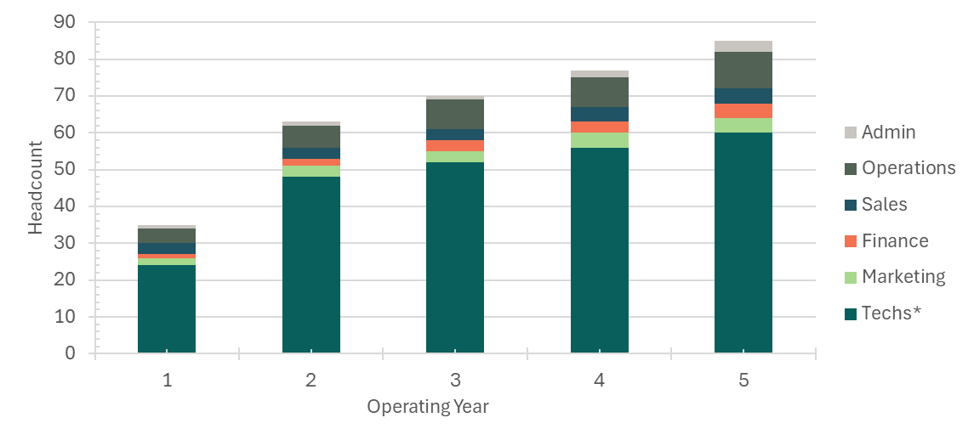

4. Services

4.1. Core services: Turn-Key Final Assembly
GPW initially specializes in system integration, final assembly, and testing/validation. Strategically located in Monterrey, Mexico to serve North American markets, GPW provides a nearshore solution that helps customers mitigate tariff and supply-chain risk while maintaining high quality and execution discipline—particularly for complex electronics and infrastructure programs where schedule reliability and documentation are critical.
Currently in the planning and build-out phase, GPW is establishing standardized workflows, control plans, and quality systems to ensure repeatable builds, clear traceability, and on-time delivery. This includes defining structured processes for kitting and staging, assembly and integration, inspection checkpoints, test execution, and final pack-out—creating a foundation that can scale while maintaining consistent performance and customer visibility.
What |  | Why
Server rack assembly according to specification |  | Ensure functionality and reliability
Multi-type boxing integration and initial testing |  | Detect faults early, preventing field failures
Multi-stage quality control |  | Drive consistent quality, audit readiness, and supplier confidence
Specialized packaging |  | Protect product during transit and storage
Lifecycle management |  | Ensure production sustainment and smooth Phase-In-Phase-Out (PIPO) of engineering changes
Domestic & international logistics |  | Cut lead times, simplify supply chain, and deliver modules straight to production

4.2. Roadmap & Milestones
The following goals have been defined.
Year 1 | → |  | Year 2-4 | → |  | Year 5
- Launch pilot line  - Validate product flow  - Achieve first commercial runs |  | - ISO 9001:2015 Certification achieved  - Scale capacity  - Improve quality and throughput  - Stabilize supply chain |  |  | - Optimize for flexibility and sustainability  - Offer value-added services

5. Market Analysis and Strategies

5.1. Geographic Markets
Considering the company’s main initial services, the markets upon which it will operate are:
- North America
- Latin America
- Europe

5.2. Total Available Market
The total available market for the services to be offered by the company is defined as the total annual revenue by manufacturing companies in the USA who have outsourced assembly, integration, and light manufacturing services that could be performed by suppliers located in Mexico.

5.2.1. Market segmentation
Industry | Estimated Value (billion USD) | Outsourced % | SAM (billion USD)
Cloud Computing Providers | $382.5 | 45% | $174.9
Social Media & Digital Platform | $177.6 | 43% | $76.75
Government and Public Sector | $71.55 | 41% | $29.14
Financial Services | $62.87 | 41% | $25.74
Healthcare and Life Science | $55.68 | 41% | $23.03
E-Commerce & Retail | $20.93 | 43% | $9.14
Telecommunications | $11.59 | 46% | $5.37
Total | $782.66 |  | $344.06

5.2.2. Top-Down Analysis

5.2.2.1. Company’s restrictions:

5.2.2.1. Company’s restrictions
- Initial services focused solely on final assembly, integration, and testing/validation.
- Target customers: mid-sized OEMs, Tier 1 and Tier 2 suppliers, and companies seeking nearshore capacity relief (including those with overcapacity constraints or schedule pressure).

5.2.2.2. Refined Top-Down Estimate:
- Relevant TAM: $782.66 billion
- Relevant SAM: $344.06 billion
- Realistic share capture in 1-2 years: 0.01% → ~ $100 million
- Potential share in 3-5 years: 0.02% → ~$223 million

5.2.3. TAM → SAM → SOM
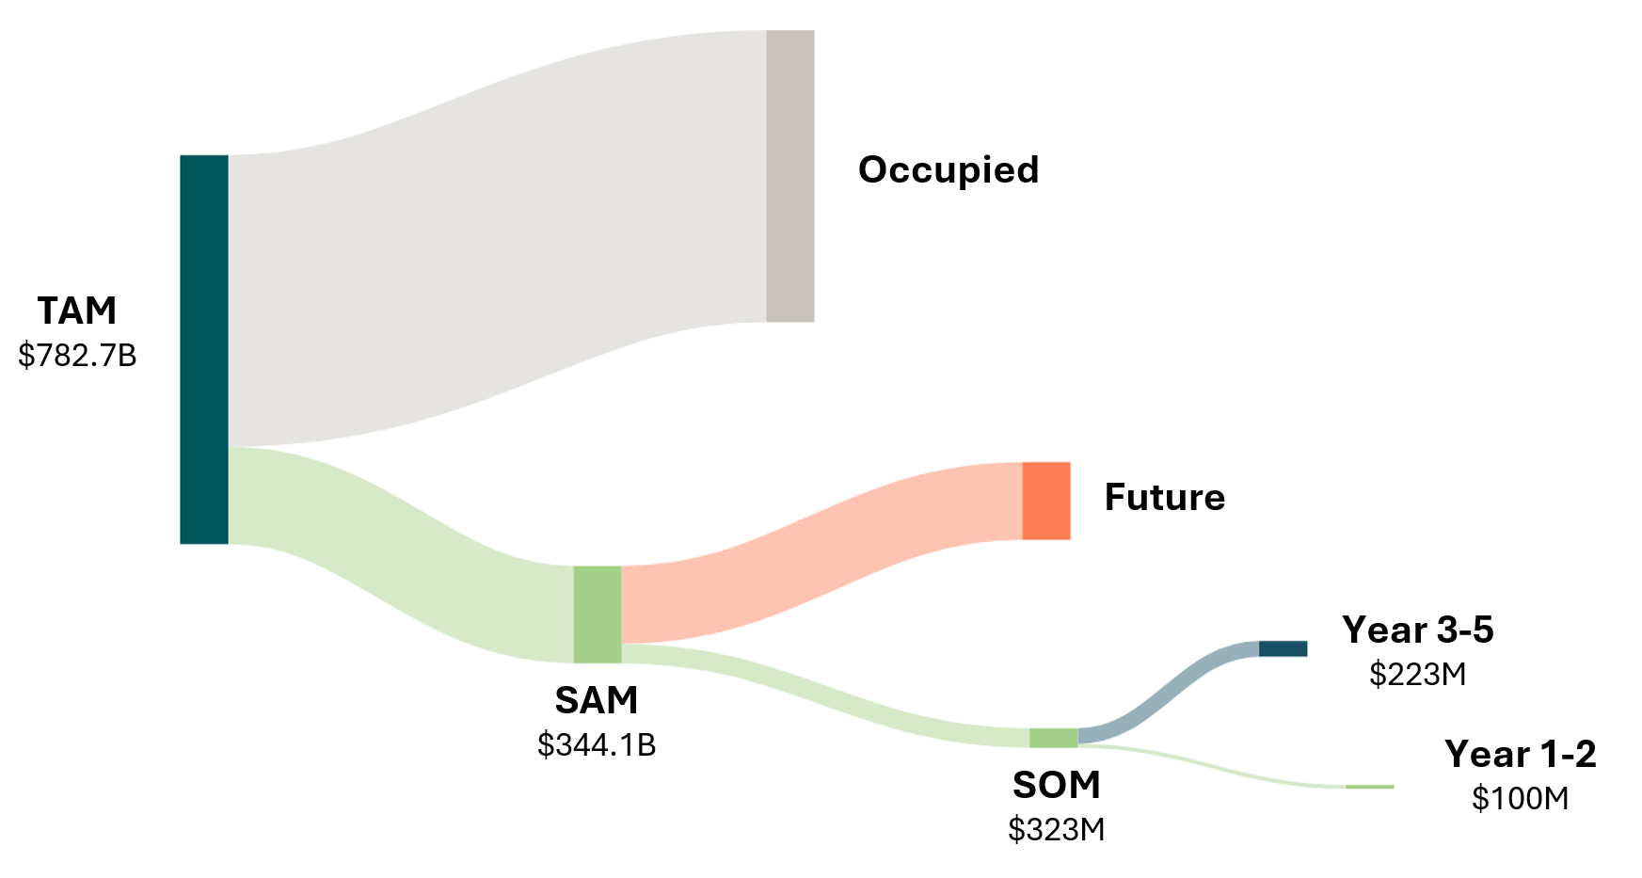
The total available market (TAM) for GPW’s relevant outsourcing opportunity is estimated at $782.66 billion USD. Based on GPW’s current service scope and go-to-market focus (integration, final assembly, and testing/validation), the serviceable available market (SAM) is estimated at $344.06 billion USD.
Given that GPW is entering the market with early-stage capacity and is building its initial operational footprint, the realistic near-term capture rate is estimated at approximately 0.01% of SAM within years 1–2, supported by targeted customer acquisition and the potential to accelerate traction through strategic alliances with existing relationships (customers, suppliers, and partners). A feasible early objective is to secure a focused set of small-to-mid-sized customers with repeatable programs that align with GPW’s integration and test capabilities.
Based on the assumptions above, GPW’s initial realistic serviceable obtainable market (SOM) for the first 1–2 years is approximately ~$100 million USD, with the potential to reach ~0.02% of SAM in years 3–5, equivalent to approximately ~$223 million USD, as capacity scales and execution maturity increases.
Year | Revenue ($M USD)
1 | $35
2 | $64
3 | $71
4 | $74
5 | $78

5.3. Sales Plan

5.3.1. Tactics

5.3.1.1. Outbound Sales:
- Targeted outreach to AI Racks, Server Racks manufacturers and assemblers in the USA and their subsidiaries in Monterrey, Guadalajara, Saltillo, Querétaro, and Juárez
- Use LinkedIn Sales Navigator, cold email, and warm intros via board of advisors’ network
- Call on the team’s current/past networks
- Reach Preferred Supplier status with assemblers and manufacturers who are experiencing over-capacity

5.3.1.2. Inbound Sales:
- Launch company website with clear value proposition and contact form.
- Post weekly updates and success stories on LinkedIn company page.
- Collect and publish client testimonials and case studies.

5.3.1.3. Networking & Partnerships:
- Leverage board of advisors to introduce the company to contract manufacturers and OEMs.
- Be a part of manufacturing consortiums (CAINTRA).
- Attend industry trade shows (e.g. CES, The Assembly Show, Hannover Messe, etc.) and set appointments in advance.
- Build referral agreements with brokers, sourcing agents, and factories with overflow.

5.3.1.4. Sales Enablement:
- Develop a slide deck, capability statement, and quote template.
- Train partners and internal team on a simple pitch + objection handling.
- Offer pilot projects or low-risk trials to onboard clients.
To ensure the estimated SOM is attained in the first five years, the following goals have been defined.
Year 1 | → |  | Year 2-4 | → |  | Year 5
- Secure 3–5 core customers in Mexico and the U.S.A.  - Achieving $35 million USD in revenue  - Build and train a repeatable sales process  - Hire first sales Rep |  | - Start an organic growth of 7.5% per year (not accounting for ramp up progress)  - Expand client base to 10+ active customers  - Develop long-term contracts or recurring projects with top 5 customers  - Hire additional reps in charge of business development and sales. (2-4 people) |  |  | - Expand to additional services (e.g., CNC, metrology, reverse engineering, packaging, logistics) transitioning to ODM.  - Develop partnerships with engineering firms.  - Enter new verticals: aerospace, energy, medical  - Explore setting up sales presence in the US

5.3.2. Growth Strategy
To manage growth in the company’s first years, the following structured plan is proposed:
Phase 1  Relationship-based Growth | → |  | Phase 2  Structured Outbound + Inbound | → |  | Phase 3  International Expansion
- Close initial deals via personal networks, referrals, and board of advisors’ introductions.  - Overdeliver to secure recurring work and future referrals.  - Launch digital marketing campaigns through social networks and email.  - Develop channel partnerships (CAINTRA) with other assemblers and integrators. |  | - Build a small sales team with clear KPIs, goals, and objectives.  - Implement a CRM system to manage leads and deals. |  |  | - Offer full service solutions: assembly + machining + fulfilment, for high-volume customers.  - Warehousing for reduced lead times under dynamic demand.

5.4. References
Full details of the estimation of the TAM-SAM-SOM, as well as their references, can be found in the document MKT-000001 - TAM SAM SOM.

6. Funding request

6.1. A summary of the business
Global Precision Works (GPW), founded in July 2025 and headquartered in Monterrey, Nuevo León, Mexico, provides high-precision integration and final assembly services for North American and global markets. Positioned at the intersection of shifting trade dynamics and the growing demand for nearshoring, GPW addresses OEM, Tier 1, and Tier 2 suppliers’ needs for shorter lead times, operational flexibility, and transparent, high-quality manufacturing.
Value Proposition
GPW combines the technical rigor of a Tier 1 supplier with the agility of a startup, offering:
- Precision + Nearshoring Advantage – Faster delivery for rack-scale builds; lower logistics risk for hyperscalers and colocation provider (COLO) operators.
- Integration Expertise – Turnkey, validated server systems ready for racking, burn‑in, and commissioning.
- Operational Flexibility – Rapid engineering-change implementation for custom configurations and urgent capacity builds.
- Digital Traceability & Quality Assurance – Full component traceability for uptime SLAs and rapid root‑cause analysis.
- Collaborative Partnership – Seamless program management with U.S. and global teams; bilingual support for field ops.
Leadership Team
- Alfredo Treviño, CCO – Mechanical engineer, expert in international commercial operations and procurement.
- Enrique Arrieta, CMO – Specialist in B2B digital marketing and strategic branding.
- Gerardo García, CFO – Corporate finance strategist with expertise in analytics and operational oversight.
- Juan Pablo Jiménez, COO – Manufacturing and operations expert with a background in advanced product development and quality management.
- Luis Alvarez, VP of Business Development - XXX
Current Status
In its startup phase, GPW has established initial operations, supplier relationships, and early client outreach, with strong market interest confirmed. Located in Monterrey’s industrial hub near the U.S. border, GPW is positioning itself as a trusted nearshore partner focused on data center infrastructure integration, final assembly, and testing/validation—supporting organizations that require reliable, and disciplined execution.
GPW’s target end-markets and customer segments include: Cloud Computing Providers; Social Media and Digital Platform companies; Government and Public Sector; Financial Services; Healthcare and Life Science; E-Commerce and Retail; and Telecommunications. These sectors increasingly depend on scalable data center capacity and place a premium on speed of deployment, consistency, traceability, and operational reliability—requirements that GPW is building its processes and quality systems to meet.

6.2. How much money you’re requesting
Capex budget (setup and needed assets): $885,357 USD
Working Capital: $5,196,358 USD
AR: 4,349,589 USD @ Net 45 Days (make financial model toN60)
AP: 3,111,000 USD @ Net 60 Days
Inventory Cycle: 3,091,709 USD @ 60 Days (assuming inventory inefficiency)
Safe plug: 20%
Founder Salaries 5 months before launch: $261,203 USD
Ramp inefficiency: $1,160,901 USD
Total funding request: $7,495,954 USD for initial launch.

6.3. What you will use the money for
The money will be used for funding the company’s foundation, meaning CAPEX related expenses. The investment is requested for working capital, inventory, initial lease payments (property rent and working machinery). Some services will be covered with the investment until sustainable operations are achieved.
According to EBIT calculation, investment will be recovered within one year as free cash flow. Considering expansion and future ramp-up developments, investment will be recovered between Years 2-3.

7. Financial Plan

7.1. Financial Statement and Budgeting & 5 Year Planning
As a startup, GPW is basing the budgeting in thorough market research, from working force to administrative positions, as well as onboarding with potential suppliers.
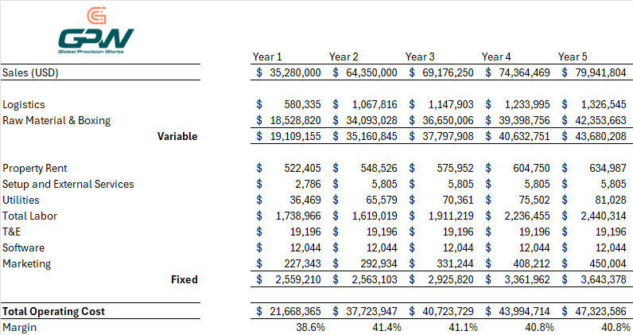
As shown in the image above, the target for Y1 (year one) will consist of $35,280,000 USD. The total operating cost for Y1 will be shortly above $21 M USD. This will leave GPW an EBITDA margin of 38.6% and a net margin of 12.3%. Y1 will leave GPW with a total of $7.9M USD of net income that will be used to rework the company and expand operations within US and Mexico.
The goal for GPW is to have a constant 30% or above EBITDA margin year over year and potentially expand the business to CNC machining to increase the revenue stream.

7.2. KPI Tracking
- EBITDA margin > 30%
- Net profit margin >10%
- Breakeven point to be achieved within year 1
- Average cost per direct cost hour to not go over $55 USD
- Cash conversion cycle < 60 days

7.3. Prospective Data
A good early goal for the sales and finance team is 35M USD. This can help the company have an early achievable goal and will let the company settle and adjust with what the market has to offer. Also considering a 20% ramp-up quarter per quarter until reaching full capacity at Year 2. After some research a healthy growth of 7.5% YoY was set for a constant and steady growth for the company. This way, GPW can set realistic goals and slowly ramp up in both the operations side and the yearly onboarding scheduled in the roadmap.
The projected budget for the company is based on thorough market research and analysis and experience of how companies structure their finances. Costs from logistics and raw materials increase linearly with the income stated, however, GPW will develop a plan to escalate the company’s size in revenue with a lower impact on cost.
Property rent has been assigned as a standard 5,000 m2 warehouse valued at a market standard price of 40,000 USD per month. Standard leases were included as external services with what operations and sales budgeted, mostly consisting of forklifts and pallet jacks.
Total labor was budgeted based on local market research with extensive databases of ongoing hiring salaries. Total direct headcount for Y1 consists of 48 operators and 4 technicians for testing. Total indirect headcount for Y1 consists of 4 founding members, 1 VP of Business Development, 1 logistics and warehouse manager, 1 local sales representative, 2 HR managers, 4 marketing team members and 5 finance team members. Headcount is projected to grow in 2 different ways: direct headcount will grow according to the established YoY growth and indirect headcount will grow with what the members project for their respective areas. Although YoY growth for direct headcount shows a higher expense for the company, there are plans for future automation that will lower the impact of GPW’s growth with the need of fewer direct headcount onboarding.
Marketing fees were budgeted hand in hand with the marketing team. The main weight of the marketing expenses come from the idea of online marketing campaigns to create more leads for the sales team to seal.

7.4. Capital Expenditure Budget
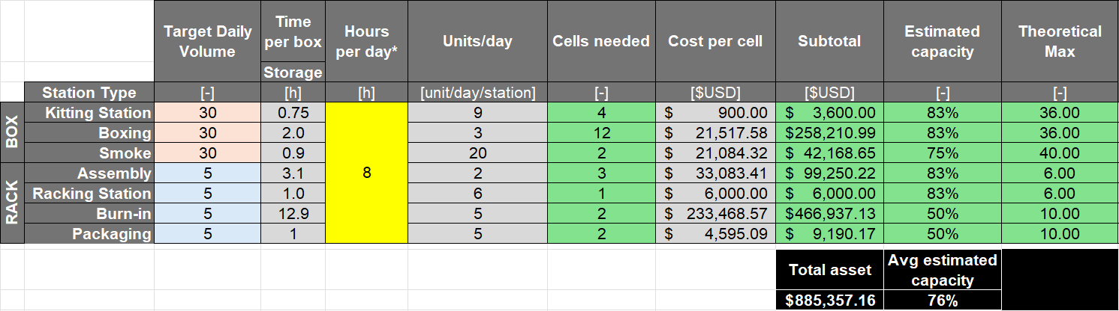
The finance and operations teams set the capex budget as $885,357.16 USD for all setup expenses.
Year 1 | → |  | Year 2-4 | → |  | Year 5
- Secure initial investment  - Sustained year-round ~30% margin:  - Break-even by month 12  - Positive cashflow  - Self-funded operations  - Budget tracking & key cost driving identification  Establish finance & data analysis team |  | - Analysis of cost centers for distinct company functions  - Improved cash cycle with credit lines or vendor financing  - Diversification of revenue streams: other industries/services included, implementation of cost centers |  |  | - Analysis for future of facilities: own vs lease & location  - Investor review for role in the company

8. Full Revision History
Level | Reason | Date | Owner | Approved
A.01 | Initial Release | 12-Aug-25 | JP Jimenez | Alfredo Treviño  Gerardo García  Enrique Arrieta
A.02 | Data Center Update | 7-Feb-26 | Alfredo Trevino

